**Breast Cancer Detection Using Mammogram Images with Deep Learning**

Esha Gangam

Department of Information Science and Technology, University at Albany, SUNY, NY, USA.

E-mail:egangam@albany.edu

**Abstract**

Breast cancer remains a significant health concern globally, demanding precise and efficient detection methodologies. This study presents an investigation into breast cancer detection utilizing mammogram images employing various machine learning models. Mammography is a widely utilized screening tool for breast cancer detection due to its effectiveness in early diagnosis. However, the interpretation of mammogram images can be subjective and prone to errors, necessitating the development of automated detection systems. The research aims to evaluate the accuracy, F1-score, and kappa measures across different algorithms. The experimental results revealed notable variations in the performance metrics across different models. However, the InceptionResNet Architecture model demonstrated superior accuracy in breast cancer detection compared to other methodologies.

Keywords: Mammogram images, Breast Cancer, Machine Learning Models, Accuracy

**Background and Motivation**

The study paper "Breast Cancer Detection using Mammogram Images with Deep Learning" explores the significance of tackling breast cancer as a worldwide health issue and clarifies the critical function of mammography in its early identification in the "Background and Motivation" section. Breast cancer is a major global health concern, as seen by the startling statistics that highlight its incidence and consequences, especially for women. The early detection of cancers is essential to the fight against this illness, and mammography is the mainstay of screening techniques. Nevertheless, there are several significant drawbacks to standard mammography methods, such as the tendency for false positives and negatives as well as inconsistent interpretation.

**1. Introduction**

Breast cancer is a common disease for women and is the second leading cause of death worldwide. According to Breast Cancer Now, breast cancer is the most common cancer in the UK. Ultrasound is the complementary modality to the standard imaging method (two-view mammography) in breast cancer diagnosis. It is the most widely used in clinical practice compared to other alternatives such as tomosynthesis and magnetic resonance imaging. Because early detection plays a main role in avoiding breast cancer deaths and increases the proportion of healing and recovery, there has been increasing interest in using ultrasound to aid in the early detection of breast cancers over the past few years1. with the advent of computer-aided diagnosis (CAD) systems, integrated with deep learning models and soft computing approaches, the diagnostic accuracy for breast cancer classification has improved significantly, reduced manual error, and increased reproducibility (Robertson et al., 2018). Recently, deep learning-based approaches have been shown to outperform conventional machine learning methods in the field of end-to-end image processing (Ching et al., 2018). Several studies on the use of deep learning approaches for breast cancer histology image analysis have been reported in the literature 2.

To reduce the death rate, early steps in disease recognition are considered. It requires an exact basis on which to distinguish benign and malignant tumors. Most frequently, medical image reports for early recognition and diagnosis of breast cancer varieties contain mammography plus ultra-sonography data. As the number of patients increases, it becomes more difficult for radiologists to complete the diagnostic process in the limited available time. The motivation of this work is to assist radiologists in increasing the rapid and accurate detection rate of breast cancer using deep learning (DL) and to compare this method to the manual system using WEKA on single images, which is more time-consuming 3.

Mammography and ultrasound are the most widely used radiological methods for early detection of breast cancer in women. These radiological methods show low specificity while having high sensitivity. Due to this reason, breast biopsies based on the results of mammography and ultrasound have been diagnosed as benign at a rate of approximately 40 to 60 percent. Negative biopsy results have negative impacts on many aspects such as unnecessary operations, fear, pain, and cost. Therefore, there is a need for a more reliable technique to reduce the number of unnecessary biopsies in the diagnosis of breast cancer. Digital mammography, which is read automatically, started to become popular due to the decrease in the accuracy of high-density mammography readings by doctors. Therefore, computer-aided diagnostic methods are very important for more accurate decisions made by doctors to solve unnecessary biopsy problem 4.

The successful markers of malignancy often applied as part of assessing mammograms are masses and micro-calcifications. Mass detection is a more difficult problem than detection of micro-calcifications, that is because of the variant in size and form found in a mammogram and masses often show poor image contrast 5.

**2. Literature review**

6 Over the years, there have been numerous attempts to develop an automated methodology for identifying breast cancers from mammographic images. Several authors have employed typical machine learning methodologies, which include preprocessing images, feature extraction, feature selection to reduce the feature size, and finally a classification algorithm to achieve the expected result. Transfer learning and Convolutional Neural Network (CNN) models, which are the most effective DL techniques currently in the medical domain, are proven to be superior to traditional methods. In current history, DL has indeed been successfully implemented in the field of medicine with impressive outcomes and outstanding performance in different challenges compared with human activity. Various medical imaging systems using transfer learning techniques have also been developed to assist physicians and specialists in effective mammogram diagnosis, care, and follow-up examination.

7 In this Tobacco explains many of the social group trends and differences and constitutes an inequity. Cervical cancer trends are plausibly explained by screening and sexual practices. Faster increases in colorectal and breast cancer among Māori are presumably due to changes in dietary and reproductive behavior, but the higher Māori breast cancer rate is unexplained.

8 To ensure appropriate image quality, all 546 collected examinations were reviewed by one radiologist (R.M.M., with 13 years of experience with digital mammography) who did not participate in the observer study. Nine cancer examinations were excluded during this revision (three because of poor image quality, three because it was not possible to link the case report form findings to the digital mammography examination, and three because the examinations showed extremely obvious signs of breast cancer). From the remaining data, a randomized selection was performed to meet the predefined distribution of examinations. The same number of examinations was included from each collection center.

9 Machine learning (ML) has become a vital part of medical imaging research. ML methods have evolved over the years from manual seeded inputs to automatic initializations. The advancements in the field of ML have led to more intelligent and self-reliant computer-aided diagnosis (CAD) systems, as the learning ability of ML methods has been constantly improving. More and more automated methods are emerging with deep feature learning and representations. Recent advancements of ML with deeper and extensive representation approaches, commonly known as deep learning (DL) approaches, have made a very significant impact on improving the diagnostics capabilities of the CAD systems.

10 In this segmentation the breast from the background first pre-processing step in computerized mammographic analysis. This problem is usually solved by dividing it into two different segmentation strategies, one for the background and another one for the pectoral muscle. In this paper we tackle this problem jointly using a supervised single strategy. Namely, from a set of manually segmented mammograms, we model each of the three regions (breast, pectoral muscle, and background) using position, intensity, and texture information. Although the approach requires a training step, it allows a fast and reliable segmentation of new mammograms. The obtained results using 149 mammograms of the MIAS database show a high degree of overlap between manual and automatic segmentation.

11 In mammography, focus has contributed to the use of deep learning (DL) models, which have been utilized by radiologists to enhance the needed processes to overcome the shortcomings of human observers. The transfer learning method is being used to distinguish malignant and benign breast cancer by fine-tuning multiple pre-trained models. In this they introduce a framework focused on the principle of transfer learning. In addition, a mixture of augmentation strategies was used to prevent overfitting and produce stable outcomes by increasing the number of mammographic images, including several rotation combinations, scaling, and shifting. On the Mammographic Image Analysis Society (MIAS) dataset, the proposed system was evaluated and achieved an accuracy of 89.5% using (residual network-50) ResNet50. The proposed system demonstrated that pre-trained classification networks are significantly more effective and efficient, making them more acceptable for medical imaging, particularly for small training datasets.

12 has Introduced how to work around CNNs and transfer learning networks to identify pre-segmented breast abnormalities in mammograms as benign or malignant, using a fusion of transfer learning visual geometry group VGG-16-16 (VGG-16) and data augmentation methods to address the tiny training data obtained from the Digital Mammography Screening Database (DDSM), achieving an accuracy of 88%. based on the double-shot transfer learning (DSTL) method, was used to enhance the total performance and accuracy of breast cancer classification pre-trained networks. DSTL uses a large dataset that is like the target dataset to fine-tune the learnable parameters (weights and biases) of the pre-trained network. The target dataset is then used to fine-tune the networks.

13 worked and presented this strikingly like ours in that it primarily trained and evaluated the model using images from the MIAS dataset. The proposed system demonstrates remarkable results that are more accurate than existing methods. Furthermore, compared with other models such as ResNet, VGG16, or DenseNet, the proposed improved ResNet50 system is lightweight. In terms of accuracy, our proposed system outperformed existing methods.

14 The sensitivity of clinical assessment, particularly in premenopausal women is low and the false-positive mammography rate is high, but the cancer/biopsy rate is sufficiently high to warrant breast biopsy if either diagnostic modality suggests a cancer. When neither modality suggests cancer, the cancer/biopsy rate is 12% in both age groups.

15 proposed a diverse features (DFeBCD) method for breast cancer detection to classify mammograms as normal or abnormal. The IRMA mammography dataset uses two classifiers, a support vector machine (SVM) and an emotion learning-inspired integrated classifier (ELiEC). The ELiE classifier performance is superior to SVM, and the accuracy rate reaches 80.30%. He used the lifting wavelet transform (LWT) to obtain the region of interest features from the breast images. The size of the feature vectors diminishes using a fusion of principal component analysis (PCA) and linear discriminant analysis (LDA) approaches. The extreme learning machine (ELM) and moth flame optimization approaches are used for the classification using the DDSM and Mammographic Image Analysis Society (MIAS) databases. This approach attained an accuracy of 98.76% and 95.80% for the DDSM and MIAS databases respectively.

16 previous breast cancer detection and classification approaches have led to better information extraction. However, there are still numerous problems that require serious attention, i.e., (i) the tumor appears in a location with significantly lower contrast, (ii) memory complexity is high, (iii) existing approaches are computationally complex and require more treatment time to identify the accurate tumor, (iv) current deep learning approaches require a large amount of training data to overcome the problems of overfitting and high computational cost, and (v) practical implementation. To resolve the above-mentioned problems, they have proposed a new breast cancer detection and classification approach.

17 has proposed the deep active learning framework (DALF) for the classification of breast cancer. This procedure consists of detailed observations of the most useful unlabeled samples inserted into the training sets. The model is then modified with a growing number of training models. The proposed deep-active learning system addresses two selection strategies: an entropy-based plan and a confidence-building plan. The approach suggested validated utilizing a histopathological image data collection available to the public, in which every image patch is binary categorized as malignant or benign. The suggested operation utilized active learning, to choose unlabeled samples for annotation and to update the increasing training set on an iterative basis. The major objective of the work is to ease a large-scale image classification annotation burden.

18 present an effective technique for mammogram classification by exploiting texture feature-based directional transform. The feature vector is obtained by using the Gabor wavelet transform. Machine learning techniques are used in the decision-making stage. Finally, the performance was tested using the DDSM database and obtained 0.939, 0.951, and 0.92 in terms of accuracy, sensitivity, and specificity, respectively. Haar wavelet decompositions are used to extract texture features.

19 Segmentation helps in eliminating or segmenting the wanted area of the image from the unwanted for further processing. Breast region extraction is useful because of the search-zone limitation of the abnormalities of the breast. Furthermore, pectoral muscles always appear in the MLO view of mammogram images. Identification and segmentation of this region are crucial considering the overlap between pectoral muscles and ROI. This study mainly aims to design and develop a fully automated segmentation technique that can detect the breast region and eliminate pectoral muscles from mammogram images. Thus, we have proposed an efficient model based on a new thresholding technique and machine learning system. Firstly, we proposed an enhancement method based on wavelet transform to detect breast boundaries in mammogram images. Secondly, ROI and unwanted ROI (pectoral muscle) have been segmented from background and artifacts by proposing a new threshold technique. Finally, a machine learning system has been built to segment ROI from unwanted ROI (pectoral muscle) for discriminating between benign and malignant. Research related to the segmentation of ROI from the MLO view of mammogram images is limited. This study highlights that mammogram segmentation is still an open research problem. The proposed solution can overcome various segmentation challenges of the MLO view of mammogram images. Moreover, the proposed segmentation method is effective and outperforms previous methods.

Many segmentation methods have been proposed and developed for the boundary of breast and pectoral muscle. However, only a few methods that use all the images in the mini-MIAS database have been evaluated quantitatively. 20The proposed algorithm is based on edge detection and scale-space concepts for breast region segmentation. A multi-level Otsu threshold an automatic algorithm was proposed to segment the breast region. The introduced model of is a fully automated pipeline based on a gradient weight map to estimate the breast boundary.

**3. Materials and Methods**

This CBIS-DDSM (Curated Breast Imaging Subset of DDSM) is an updated and standardized version of the Digital Database for Screening Mammography (DDSM). The dataset contains images of mammograms along with annotations and metadata. Mammograms are X-ray images of the breast used to detect and diagnose breast cancer.

**3.1 Methods**

**3.1.1 - InceptionResNet Architecture:**

InceptionResNet architecture combines the strengths of both Inception and ResNet models, offering improved feature extraction and representation capabilities. In breast cancer detection from mammogram images, this architecture's deep and intricate network structure allows for capturing intricate patterns and subtle features indicative of cancerous tissue. Its advanced design facilitates learning hierarchical features, aiding in the identification of subtle abnormalities crucial for early cancer detection. Additionally, the integration of residual connections enhances gradient flow during training, enabling more efficient optimization and potentially reducing the risk of overfitting. Overall, the InceptionResNet architecture contributes to enhanced accuracy and robustness in breast cancer detection from mammogram images, thereby improving patient outcomes through early diagnosis and intervention 21.

**3.1.2 - ResNet50 Architecture:**

The ResNet50 architecture, renowned for its deep convolutional layers and residual connections, is highly beneficial in breast cancer detection from mammogram images. Its deep structure enables the extraction of intricate features crucial for discerning subtle abnormalities indicative of breast cancer. Moreover, residual connections alleviate the vanishing gradient problem, facilitating more effective training and enabling the model to learn intricate patterns present in mammogram images. By leveraging ResNet50, the detection model can achieve higher accuracy and robustness, crucial for early and reliable diagnosis of breast cancer, ultimately leading to improved patient outcomes and treatment efficacy 22.

**3.1.3 - VGG16:**

VGG16, with its deep architecture composed of multiple convolutional layers, is valuable in breast cancer detection from mammogram images due to its ability to capture hierarchical features. In mammograms, subtle abnormalities indicative of cancer may manifest in varying sizes and shapes. VGG16's deep convolutional layers enable it to extract complex features at different scales, aiding in the identification of such abnormalities. Its simplicity and uniform architecture make it easier to interpret and fine-tune for specific tasks, such as detecting breast lesions. By leveraging VGG16, the detection model can effectively learn and discriminate between benign and malignant tissues in mammogram images, contributing to accurate and early diagnosis of breast cancer, thus improving patient outcomes 23.

**3.1.4 - VGG19:**

VGG19, an extension of VGG16 with deeper layers, offers enhanced feature extraction capabilities crucial for breast cancer detection from mammogram images. With its increased depth, VGG19 can capture more intricate patterns and subtle details present in mammograms, aiding in the identification of abnormalities indicative of cancerous tissue. The hierarchical nature of VGG19's architecture allows it to learn features at multiple levels of abstraction, enabling the model to distinguish between benign and malignant lesions more effectively. Additionally, VGG19's uniform structure simplifies interpretation and fine-tuning for mammogram-specific tasks, facilitating model optimization and performance improvement. By leveraging VGG19, detection models can achieve higher accuracy and reliability in diagnosing breast cancer from mammogram images, thereby supporting early intervention and improving patient outcomes 24.

**3.1.5 - MobilenetV2:**  
MobileNetV2, designed for efficient computation and deployment on mobile and embedded devices, offers unique advantages in breast cancer detection from mammogram images. Despite its lightweight architecture, MobileNetV2 retains powerful feature extraction capabilities, making it suitable for resource-constrained environments like medical imaging systems. In mammogram analysis, where processing large volumes of data is common, MobileNetV2's efficiency enables faster inference without compromising accuracy. Its depth-wise separable convolutions reduce the computational burden while preserving discriminative features crucial for identifying cancerous abnormalities. Additionally, MobileNetV2's adaptability facilitates integration into diverse healthcare settings, including remote or low-resource areas, thereby expanding access to early breast cancer diagnosis. Leveraging MobileNetV2 can lead to efficient and scalable breast cancer detection solutions, improving patient outcomes through timely intervention and treatment 25.

**3.1.6 - Convolution 2Layer Deep:**

A Convolutional Neural Network (CNN) with two deep convolutional layers is beneficial in breast cancer detection from mammogram images due to its ability to learn hierarchical features effectively. In mammograms, subtle abnormalities indicative of cancer may exist at various scales and orientations. By employing multiple convolutional layers, the CNN can capture intricate patterns and textures present in the mammogram images, enabling it to discern between normal and abnormal tissues more accurately. Additionally, the hierarchical feature extraction process allows the model to focus on relevant regions of interest, enhancing its sensitivity to potential cancerous lesions. Moreover, the trainable nature of CNNs enables the model to adapt and optimize its parameters based on the dataset, improving its performance in breast cancer detection tasks. Overall, a CNN with two deep convolutional layers offers a robust and efficient approach for identifying breast cancer from mammogram images, potentially leading to earlier diagnosis and improved patient outcomes 26.

**3.1.7 - Conv 3 Layer Deep:**

A Convolutional Neural Network (CNN) with three deep convolutional layers is particularly useful in breast cancer detection from mammogram images due to its enhanced capacity to extract intricate features and patterns. Mammogram images often contain subtle abnormalities that may signify the presence of cancerous tissue. By incorporating three deep convolutional layers, the CNN can effectively capture and analyze complex spatial information present in the images, allowing for more comprehensive feature representation. This deeper architecture enables the model to learn hierarchical features at multiple levels of abstraction, enhancing its ability to discriminate between benign and malignant tissues with greater accuracy 27.

**3.1.8-MobileNet**  
  
MobileNet's lightweight design enables efficient computation, making it suitable for real-time breast cancer detection from mammogram images. Its scalability allows deployment across diverse platforms, expanding access to screening tools. Despite its size, MobileNet effectively extracts relevant features crucial for identifying cancerous abnormalities. By fine-tuning MobileNet on mammogram datasets, it can accurately classify normal and abnormal tissue, aiding in early diagnosis. Overall, MobileNet offers a practical and adaptable solution for improving breast cancer detection, particularly in resource-constrained or remote healthcare settings 28.

**3.1.9-InceptionResNetV2**  
InceptionResNetV2's fusion of Inception and ResNet architectures enables precise feature extraction from mammogram images, aiding in the identification of subtle cancerous abnormalities. Its deep network structure facilitates hierarchical learning, enhancing sensitivity to lesions at different scales. Residual connections optimize training, mitigating overfitting risks and improving model generalization. With its interpretability and state-of-the-art performance, InceptionResNetV2 offers a reliable tool for accurate and early breast cancer detection, crucial for timely intervention and improved patient outcomes 29.

**3.1.10-ResNet101**  
ResNet101, a deeper variant of the ResNet architecture, offers enhanced capability in breast cancer detection from mammogram images. Its deep layers enable the extraction of intricate features crucial for identifying subtle abnormalities indicative of cancerous tissue. With residual connections, it mitigates the vanishing gradient problem, facilitating more efficient training and enabling the model to learn complex patterns present in mammogram images. Its adaptability allows fine-tuning on mammogram datasets, optimizing performance for this specific task. Leveraging ResNet101 can lead to improved accuracy in detecting breast cancer from mammogram images, aiding in early diagnosis, and enhancing patient outcomes 30.

**4. Result**

**4.1 Data**

This CBIS-DDSM (Curated Breast Imaging Subset of DDSM) is an updated and standardized version of the Digital Database for Screening Mammography (DDSM). The dataset contains images of mammograms along with annotations and metadata. Mammograms are X-ray images of the breast used to detect and diagnose breast cancer. The dataset is likely intended for research and development purposes in the field of medical imaging, particularly for breast cancer detection and diagnosis. The DDSM is a database of 2,620 scanned film mammography studies. The data set contains 753 calcification cases and 891 mass cases, providing a data set size capable of analyzing decision support systems in mammography. It contains normal, benign, and malignant cases with verified pathology information. The images have been decompressed and converted to DICOM format. Researchers can use this dataset to train machine learning models for various tasks related to breast cancer detection and diagnosis. This may include tasks such as classification of mammograms as benign or malignant, segmentation of lesions, or predicting patient outcomes.

The image data for this collection is structured such that each participant has multiple patient IDs. For example, participant 00038 has 10 separate patient IDs which provide information about the scans within the IDs (e.g. Calc-Test_P_00038_LEFT_CC, Calc-Test_P_00038_RIGHT_CC_1). This makes it appear as though there are 6,671 patients according to the DICOM metadata, but there are only 1,566 actual participants in the cohort.

**4.2 Performance and Evaluation**

Accuracy, Cohen's kappa coefficient, F1-score, and AUC are frequently used as performance indicators to evaluate the efficacy of the generated models in the identification of Breast cancer using Mammography images.

**4.2.1. Accuracy:**

Accuracy is a fundamental performance measure that indicates the proportion of correctly classified instances out of the total instances. In the context of breast cancer detection, accuracy represents the overall correctness of the model in classifying mammogram images as either indicative of cancerous or non-cancerous conditions. High accuracy suggests that the model is making correct predictions on a majority of the samples, indicating its effectiveness in distinguishing between malignant and benign cases. However, accuracy alone may not provide a comprehensive understanding of model performance, especially in imbalanced datasets.

**4.2.2. Cohen's Kappa Coefficient:**

Cohen's kappa coefficient is a statistic that measures the agreement between predicted and observed classifications while accounting for the possibility of agreement occurring by chance. In breast cancer detection projects, Cohen's kappa is used to assess the inter-rater agreement or consistency between the model's predictions and the ground truth labels provided by experts. A high kappa value indicates a strong agreement between predicted and actual classifications beyond what would be expected by chance alone.

**4.2.3. F1-Score:**

The F1-score is the harmonic mean of precision and recall, providing a balanced measure of a model's performance in terms of both false positives and false negatives. In breast cancer detection, F1-score is crucial as it considers both the ability of the model to correctly identify positive instances (sensitivity/recall) and its capability to avoid misclassifying negative instances(precision). A high F1 score indicates a model's ability to achieve both high precision and recall simultaneously.

**4.2.4. Area Under Curve (AUC):**

The AUC metric assesses the discriminative ability of a binary classifier across various decision thresholds by plotting the true positive rate (sensitivity) against the false positive rate (1 - specificity).In breast cancer detection projects, AUC quantifies the model's ability to distinguish between cancerous and non-cancerous cases across different levels of sensitivity and specificity. A higher AUC value indicates better discriminatory power of the model.

**4.3 Experimental Results**

4.3.1.InceptionResNet Architecture:

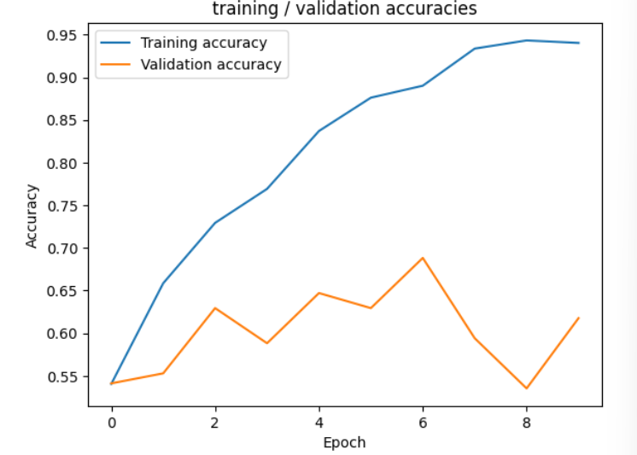 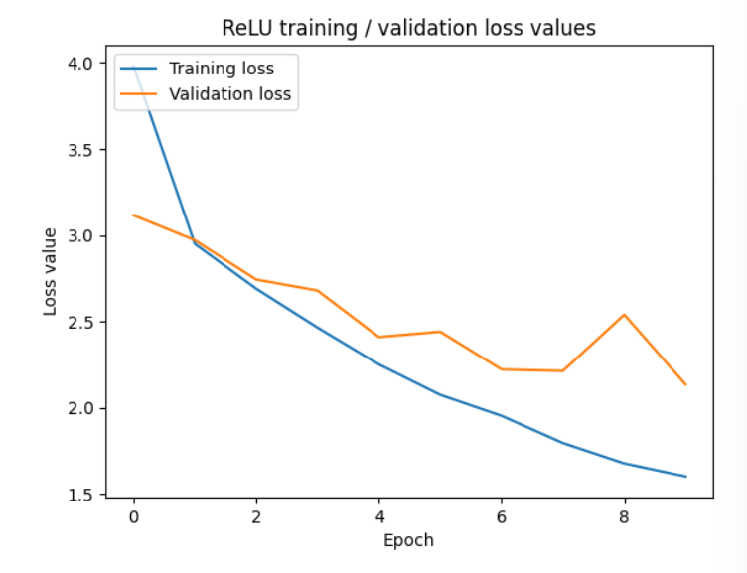

4.3.2.ResNet50 Architecture:

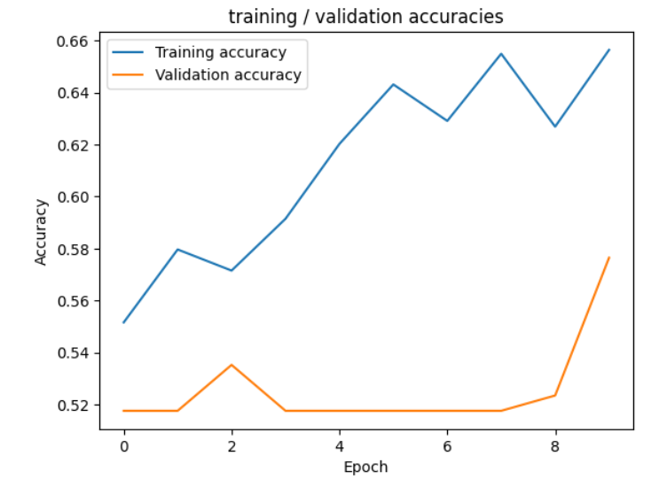 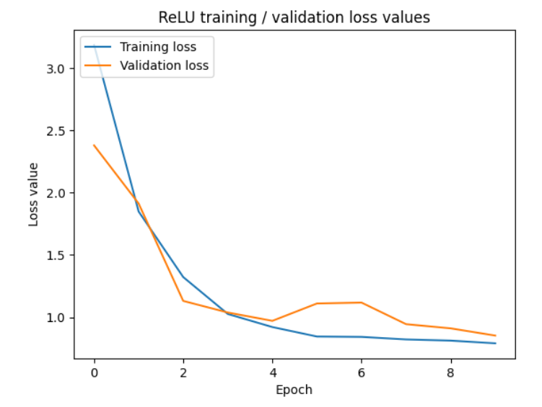

4.3.3.VGG16:

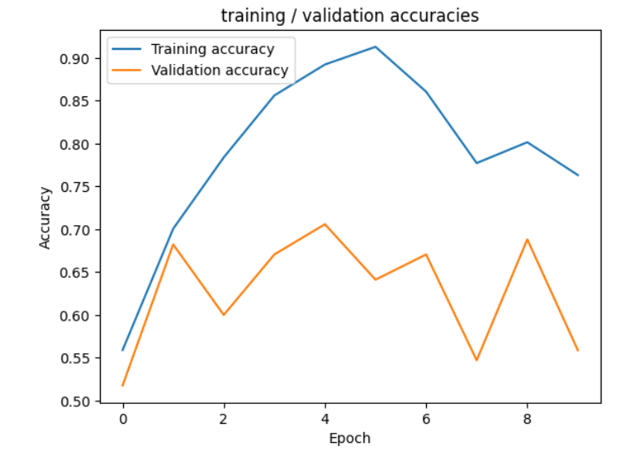 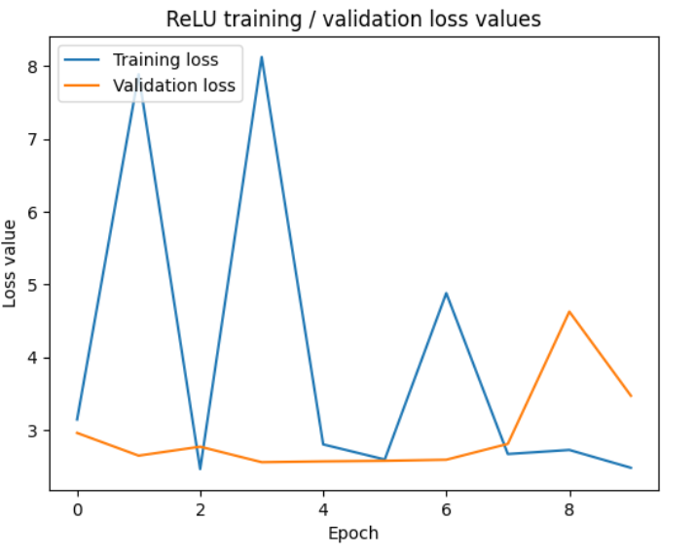

4.3.4.VGG19:

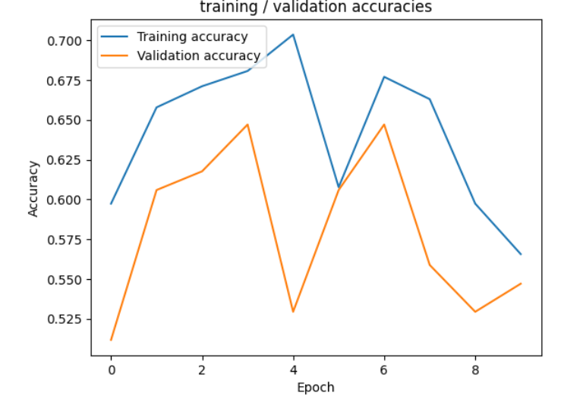 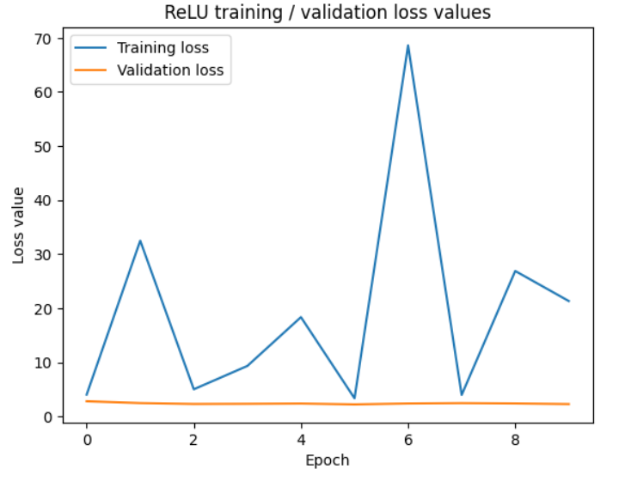

4.3.5.MobilenetV2:

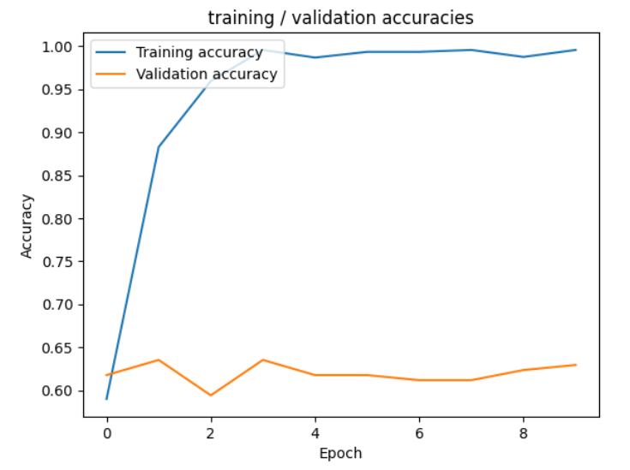 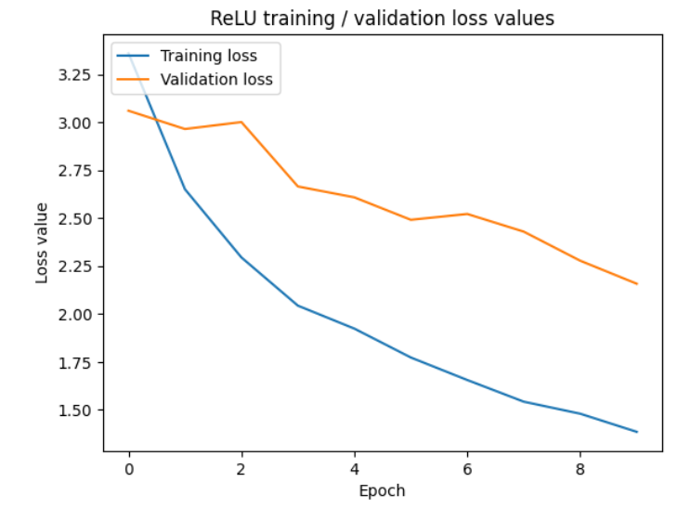

4.3.6.Convolution 2 Layer Deep:

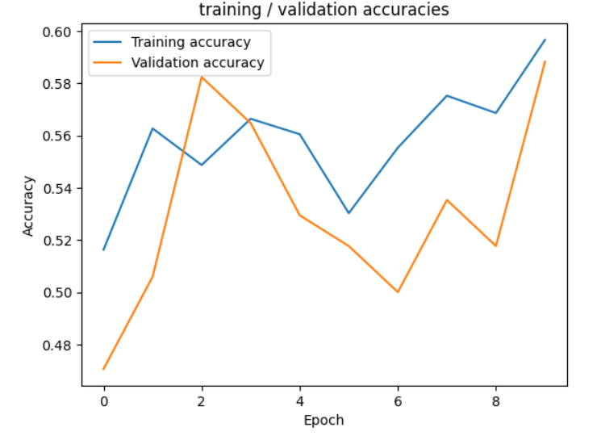 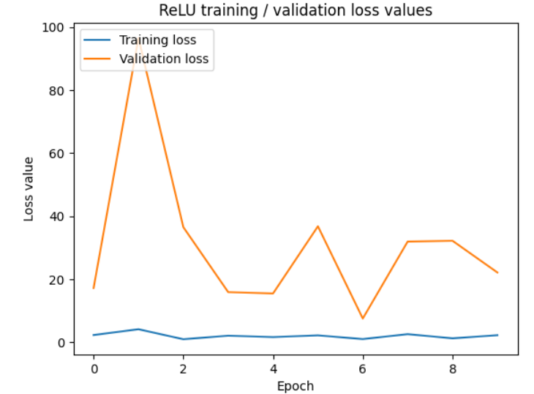

4.3.7.Convolution 2 Layer Deep:

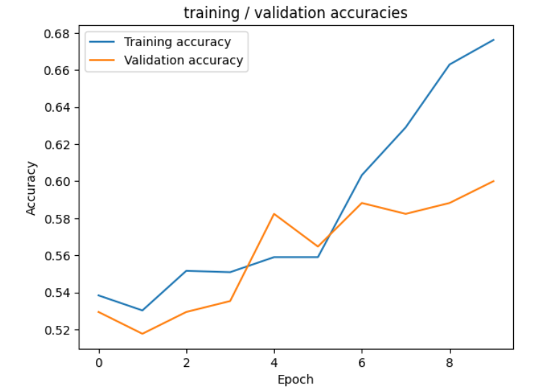 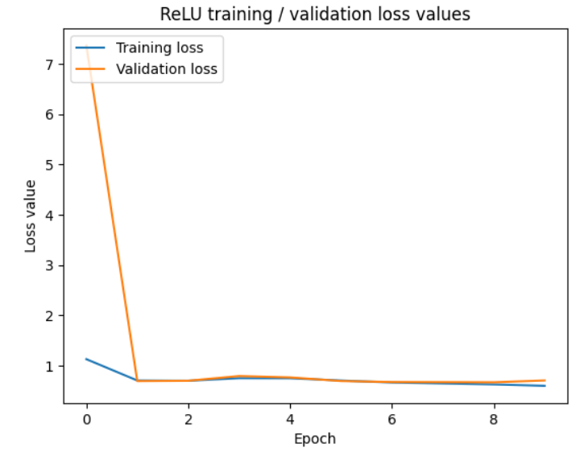

4.3.8.MobileNet:

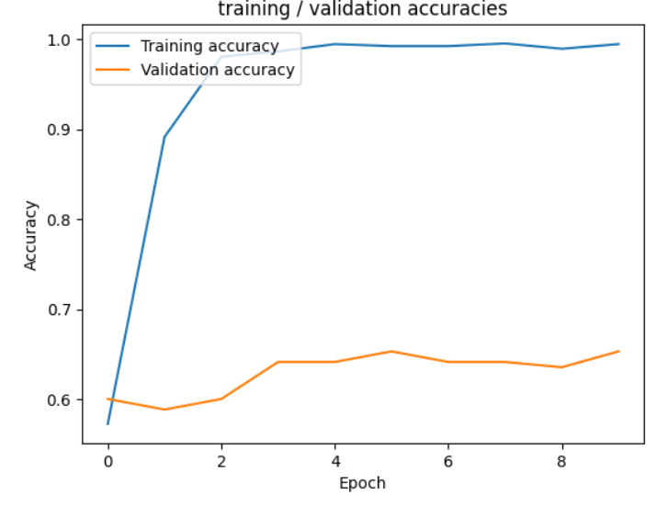 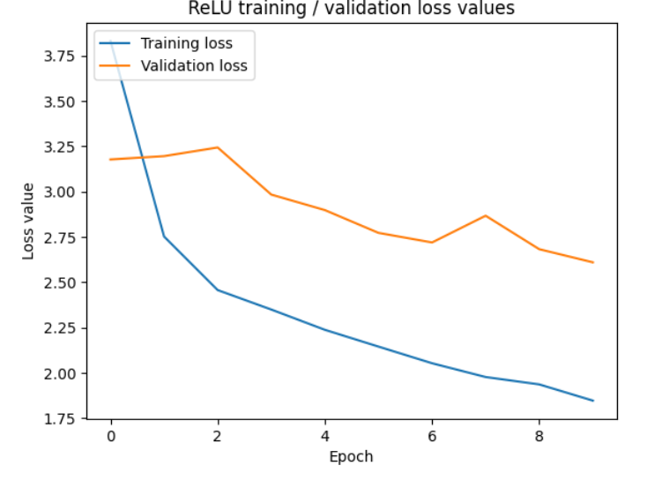

4.3.9.InceptionResNetV2:

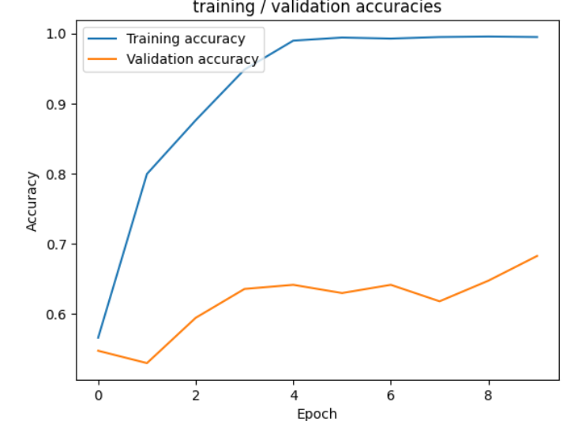 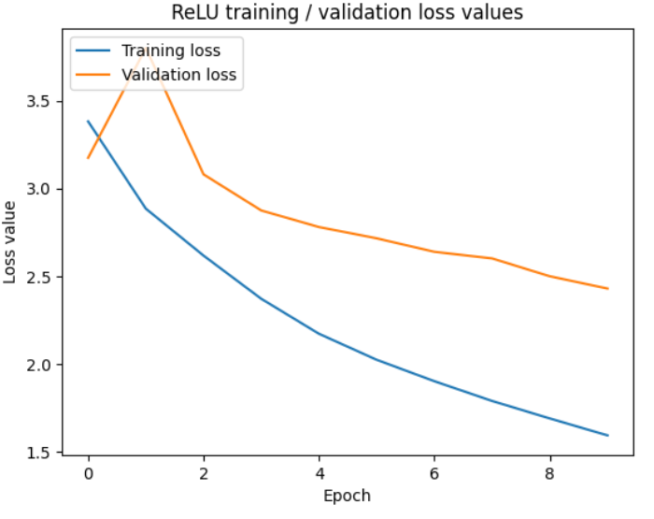

4.3.10.ResNet101:

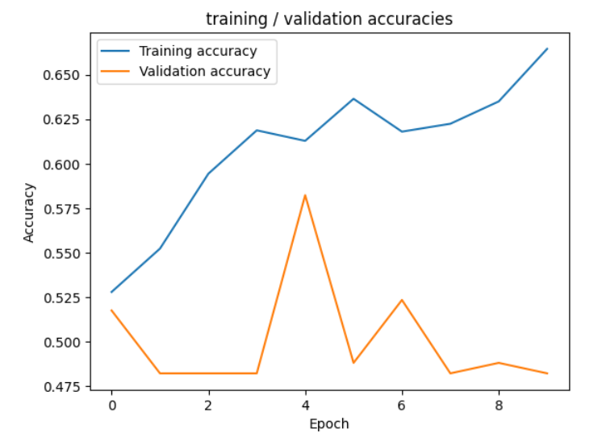 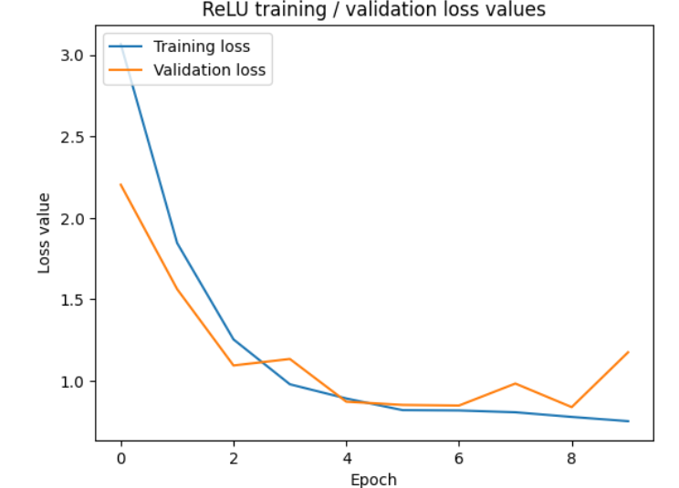

**Comparison Table:**

|  |  |  |  |  |  |
| --- | --- | --- | --- | --- | --- |
| **S.NO** | **Model** | Accuracy | AUC | F1 score | Cohen Kappa |
| 1. | InceptionResNet Architecture | 0.9403 | 0.5420 | 0.5217 | -0.9243 |
| 2. | ResNet50 Architecture | 0.6563 | 0.5530 | 0.5428 | -0.9423 |
| 3. | VGG16 | 0.7633 | 0.5948 | 0.5406 | -0.9389 |
| 4. | VGG19 | 0.5656 | 0.6216 | 0.5751 | - 0.9132 |
| 5. | MobilenetV2 | 0.9401 | 0.6126 | 0.5714 | - 0.9729 |
| 6. | Convolution 2Layer Deep | 0.5966 | 0.5235 | 0.4936 | - 0.8744 |
| 7. | Conv 3 Layer Deep | 0.6763 | 0.5396 | 0.4642 | - 0.7391 |
| 8. | MobileNet | 0.5948 | 0.5866 | 0.5589 | - 0.6294 |
| 9. | InceptionResNetV2 | 0.6948 | 0.5866 | 0.5625 | - 0.9685 |
| 10. | ResNet101 | 0.6645 | 0.5462 | 0.5328 | - 0.9672 |

**4.4 Experimental Findings Discussions**

1. **Dataset Acquisition**: We obtained a comprehensive dataset of mammogram images from renowned medical repositories and databases. These images have a different range of cases, including both malignant and benign instances, to ensure the robustness and generalizability of our models.
2. **Data Preprocessing**: Firstly, we need to model training, we performed preprocessing steps to standardize the dataset and enhance its quality. This involved resizing the images to a uniform resolution, normalizing pixel values, and applying techniques such as histogram equalization to improve contrast and visibility of features.
3. **Dataset Split:**  The collected images, we had split into the three groups, the first group is training set. We used this group to teach our computer models what cancer looks like in mammogram pictures. The next group was the validation set. We used these pictures to make sure our models were learning well. If they weren't, we could adjust some settings to help them learn better. The last group was the test set. We saved these pictures until the very end. We wanted to see if our models could still find cancer in new pictures they hadn't seen before.
4. **Model Architecture selection:**  We experimented with a variety of deep learning architectures suitable for image classification tasks. These included convolutional neural networks (CNNs) such as ResNet50, VGG16, VGG19, InceptionResNetV2, and MobileNetV2.s
5. **Implementation**: The deep learning models were implemented using TensorFlow and Kera’s, two widely used frameworks for building neural networks. Once training was completed, the trained models were evaluated using the previously untouched test set.

**5. Conclusion**

our study shows that using advanced computer techniques can help find breast cancer better in mammogram pictures. We found that certain computer models, like InceptionResNet Architecture, are good at spotting cancer in these pictures.

While this is promising, we still need more data and better ways to understand how these models work. But overall, our research suggests that using these advanced computer methods could make a big difference in finding breast cancer early, which is key for saving lives.

**6. References**

1. Yap MH, Goyal M, Osman F, Martí R, Denton E, Juette A, et al. Breast ultrasound region of interest detection and lesion localization. Artif Intell Med [Internet]. 2020 Jul [cited 2024 Apr 24];107:101880. Available from: https://linkinghub.elsevier.com/retrieve/pii/S0933365719306670

2. Bhowal P, Sen S, Velasquez JD, Sarkar R. Fuzzy ensemble of deep learning models using choquet fuzzy integral, coalition game and information theory for breast cancer histology classification. Expert Syst Appl [Internet]. 2022 Mar [cited 2024 Apr 24];190:116167. Available from: https://linkinghub.elsevier.com/retrieve/pii/S0957417421014883

3. Kaur P, Singh G, Kaur P. Intellectual detection and validation of automated mammogram breast cancer images by multi-class SVM using deep learning classification. Inform Med Unlocked [Internet]. 2019 [cited 2024 Feb 25];16:100151. Available from: https://linkinghub.elsevier.com/retrieve/pii/S2352914818301813

4. Hepsag PU, Ozel SA, Yazici A. Using deep learning for mammography classification. In: 2017 International Conference on Computer Science and Engineering (UBMK) [Internet]. Antalya: IEEE; 2017 [cited 2024 Feb 25]. p. 418–23. Available from: http://ieeexplore.ieee.org/document/8093429/

5. Kolb TM, Lichy J, Newhouse JH. Comparison of the Performance of Screening Mammography, Physical Examination, and Breast US and Evaluation of Factors that Influence Them: An Analysis of 27,825 Patient Evaluations. Radiology [Internet]. 2002 Oct [cited 2024 Apr 24];225(1):165–75. Available from: http://pubs.rsna.org/doi/10.1148/radiol.2251011667

6. Chatfield K, Simonyan K, Vedaldi A, Zisserman A. Return of the Devil in the Details: Delving Deep into Convolutional Nets. 2014 [cited 2024 Apr 24]; Available from: https://arxiv.org/abs/1405.3531

7. Blakely T, Shaw C, Atkinson J, Cunningham R, Sarfati D. Social inequalities or inequities in cancer incidence? Repeated census-cancer cohort studies, New Zealand 1981–1986 to 2001–2004. Cancer Causes Control [Internet]. 2011 Sep [cited 2024 Feb 25];22(9):1307–18. Available from: http://link.springer.com/10.1007/s10552-011-9804-x

8. Rodríguez-Ruiz A, Krupinski E, Mordang JJ, Schilling K, Heywang-Köbrunner SH, Sechopoulos I, et al. Detection of Breast Cancer with Mammography: Effect of an Artificial Intelligence Support System. Radiology [Internet]. 2019 Feb [cited 2024 Apr 24];290(2):305–14. Available from: http://pubs.rsna.org/doi/10.1148/radiol.2018181371

9. Gardezi SJS, Elazab A, Lei B, Wang T. Breast Cancer Detection and Diagnosis Using Mammographic Data: Systematic Review. J Med Internet Res. 2019 Jul 26;21(7):e14464.

10. Oliver A, Llado X, Torrent A, Marti J. One-shot segmentation of breast, pectoral muscle, and background in digitised mammograms. In: 2014 IEEE International Conference on Image Processing (ICIP) [Internet]. Paris, France: IEEE; 2014 [cited 2024 Apr 24]. p. 912–6. Available from: http://ieeexplore.ieee.org/document/7025183/

11. Alruwaili M, Gouda W. Automated Breast Cancer Detection Models Based on Transfer Learning. Sensors [Internet]. 2022 Jan 24 [cited 2024 Feb 25];22(3):876. Available from: https://www.mdpi.com/1424-8220/22/3/876

12. Hussain Z, Gimenez F, Yi D, Rubin D. Differential Data Augmentation Techniques for Medical Imaging Classification Tasks. AMIA Annu Symp Proc AMIA Symp. 2017;2017:979–84.

13. Charan S, Khan MJ, Khurshid K. Breast cancer detection in mammograms using convolutional neural network. In: 2018 International Conference on Computing, Mathematics and Engineering Technologies (iCoMET) [Internet]. Sukkur: IEEE; 2018 [cited 2024 Apr 24]. p. 1–5. Available from: https://ieeexplore.ieee.org/document/8346384/

14. Sterns EE. Relation between clinical and mammographic diagnosis of breast problems and the cancer/biopsy rate. Can J Surg J Can Chir. 1996 Apr;39(2):128–32.

15. Chouhan N, Khan A, Shah JZ, Hussnain M, Khan MW. Deep convolutional neural network and emotional learning based breast cancer detection using digital mammography. Comput Biol Med [Internet]. 2021 May [cited 2024 Apr 24];132:104318. Available from: https://linkinghub.elsevier.com/retrieve/pii/S0010482521001128

16. Maqsood S, Damaševičius R, Maskeliūnas R. TTCNN: A Breast Cancer Detection and Classification towards Computer-Aided Diagnosis Using Digital Mammography in Early Stages. Appl Sci [Internet]. 2022 Mar 23 [cited 2024 Apr 24];12(7):3273. Available from: https://www.mdpi.com/2076-3417/12/7/3273

17. Qi Q, Li Y, Wang J, Zheng H, Huang Y, Ding X, et al. Label-Efficient Breast Cancer Histopathological Image Classification. IEEE J Biomed Health Inform [Internet]. 2019 Sep [cited 2024 Apr 24];23(5):2108–16. Available from: https://ieeexplore.ieee.org/document/8561292/

18. Ghasemzadeh A, Sarbazi Azad S, Esmaeili E. Breast cancer detection based on Gabor-wavelet transform and machine learning methods. Int J Mach Learn Cybern [Internet]. 2019 Jul [cited 2024 Apr 24];10(7):1603–12. Available from: http://link.springer.com/10.1007/s13042-018-0837-2

19. Zebari DA, Zeebaree DQ, Abdulazeez AM, Haron H, Hamed HNA. Improved Threshold Based and Trainable Fully Automated Segmentation for Breast Cancer Boundary and Pectoral Muscle in Mammogram Images. IEEE Access [Internet]. 2020 [cited 2024 Apr 24];8:203097–116. Available from: https://ieeexplore.ieee.org/document/9249425/

20. Shi P, Zhong J, Rampun A, Wang H. A hierarchical pipeline for breast boundary segmentation and calcification detection in mammograms. Comput Biol Med [Internet]. 2018 May [cited 2024 Apr 24];96:178–88. Available from: https://linkinghub.elsevier.com/retrieve/pii/S0010482518300623

21. Szegedy C, Vanhoucke V, Ioffe S, Shlens J, Wojna Z. Rethinking the Inception Architecture for Computer Vision. 2015 [cited 2024 Apr 25]; Available from: https://arxiv.org/abs/1512.00567

22. He K, Zhang X, Ren S, Sun J. Identity Mappings in Deep Residual Networks. 2016 [cited 2024 Apr 25]; Available from: https://arxiv.org/abs/1603.05027

23. Deng J, Dong W, Socher R, Li LJ, Kai Li, Li Fei-Fei. ImageNet: A large-scale hierarchical image database. In: 2009 IEEE Conference on Computer Vision and Pattern Recognition [Internet]. Miami, FL: IEEE; 2009 [cited 2024 Apr 27]. p. 248–55. Available from: https://ieeexplore.ieee.org/document/5206848/

24. Bansal M, Kumar M, Sachdeva M, Mittal A. Transfer learning for image classification using VGG19: Caltech-101 image data set. J Ambient Intell Humaniz Comput [Internet]. 2023 Apr [cited 2024 Apr 27];14(4):3609–20. Available from: https://link.springer.com/10.1007/s12652-021-03488-z

25. Sandler M, Howard A, Zhu M, Zhmoginov A, Chen LC. MobileNetV2: Inverted Residuals and Linear Bottlenecks. 2018 [cited 2024 Apr 27]; Available from: https://arxiv.org/abs/1801.04381

26. An Q, Chen W, Shao W. A Deep Convolutional Neural Network for Pneumonia Detection in X-ray Images with Attention Ensemble. Diagnostics [Internet]. 2024 Feb 11 [cited 2024 Apr 27];14(4):390. Available from: https://www.mdpi.com/2075-4418/14/4/390

27. Alzubaidi L, Zhang J, Humaidi AJ, Al-Dujaili A, Duan Y, Al-Shamma O, et al. Review of deep learning: concepts, CNN architectures, challenges, applications, future directions. J Big Data [Internet]. 2021 Mar 31 [cited 2024 Apr 27];8(1):53. Available from: https://journalofbigdata.springeropen.com/articles/10.1186/s40537-021-00444-8

28. Rybczak M, Kozakiewicz K. Deep Machine Learning of MobileNet, Efficient, and Inception Models. Algorithms [Internet]. 2024 Feb 22 [cited 2024 Apr 27];17(3):96. Available from: https://www.mdpi.com/1999-4893/17/3/96

29. Mondal MRH, Bharati S, Podder P. CO-IRv2: Optimized InceptionResNetV2 for COVID-19 detection from chest CT images. Raja G, editor. PLOS ONE [Internet]. 2021 Oct 28 [cited 2024 Apr 27];16(10):e0259179. Available from: https://dx.plos.org/10.1371/journal.pone.0259179

30. Zhang Q. A novel ResNet101 model based on dense dilated convolution for image classification. SN Appl Sci [Internet]. 2022 Jan [cited 2024 Apr 27];4(1):9. Available from: https://link.springer.com/10.1007/s42452-021-04897-7